1. Created new Language ServiceA computer screen shot of a computer

   AI-generated content may be incorrect.
2. Access <https://language.cognitive.azure.com/home>
3. Select the option “Sentiment and opinion mining tryout” A screenshot of a computer

   AI-generated content may be incorrect.
4. Select the text language and the resource to be usedA screenshot of a computer

   AI-generated content may be incorrect.
5. Write the text to be analized (remember, this may incur costs) A screenshot of a computer

   AI-generated content may be incorrect.
6. Press the ‘run’ button to generate the analysis.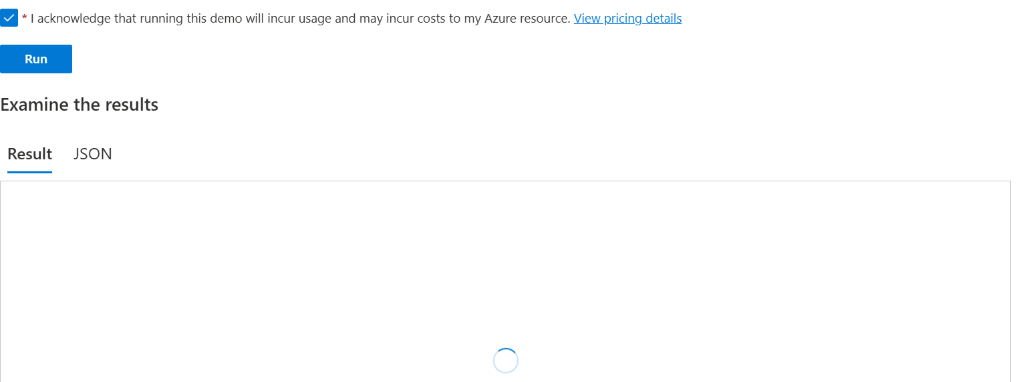
7. The output will bring the analysis made by the AI, displaying the % of certainty about the emotions and highlighting the relevant words or phrases. A screenshot of a computer

   AI-generated content may be incorrect.

This kind of technology can bring many benefits for processes where the satisfaction is a metric to keep track of, allowing filtering and sorting customers answers to generate metrics, and action plans to leverage the services/products.